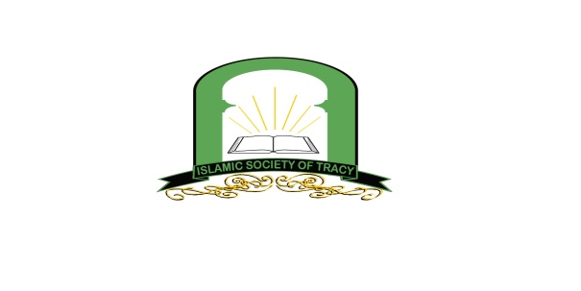
انجمن اسلامی ترسی

مسجد امام بخاری (رح)
(Imam Bukhari Masjid)
Islamic Society of Tracy presents..
END OF SCHOOL YEAR CEREMONY
Please join us as we recognize our student’s efforts in our Saturday School End Of Year Ceremony

When: Sunday, June 22, 2014 12:00 Noon to 4:00 p.m.
Where: Veteran's Park, Glenhaven Drive, Tracy, CA
This is a potluck. Parents, please bring enough food and drinks for your family and share them with other families. Thank you.
Agenda

12:00 pm Start of Program
1:00 p.m. LUNCH
2:00 pm Quran recitation by students
2:30 pm Awards and Certificates presented
3:00pm Activities
4:00 pm End of program (parents please assist with clean up

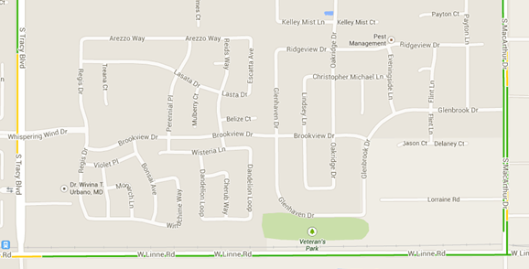

For additional information please contact:
Moheb Arghandiwal: 209-814-5691 or Zabih Zaca: 209-401-3297

Upcoming Dates
Registration for 2014-15 School Year: July 19 & July 26 9:00am-12:00pm
2014-2015 School Year begins: Saturday August 9th, 2014

